Module 02 - Part 1: Hands-On Project 3-1: Using OpenPuff Steganography
Jadon Kosberg
- Click Manual to open the OpenPuff manual. Save this file to your computer. Read through the manual to see the different features available. Return to the home page when finished.
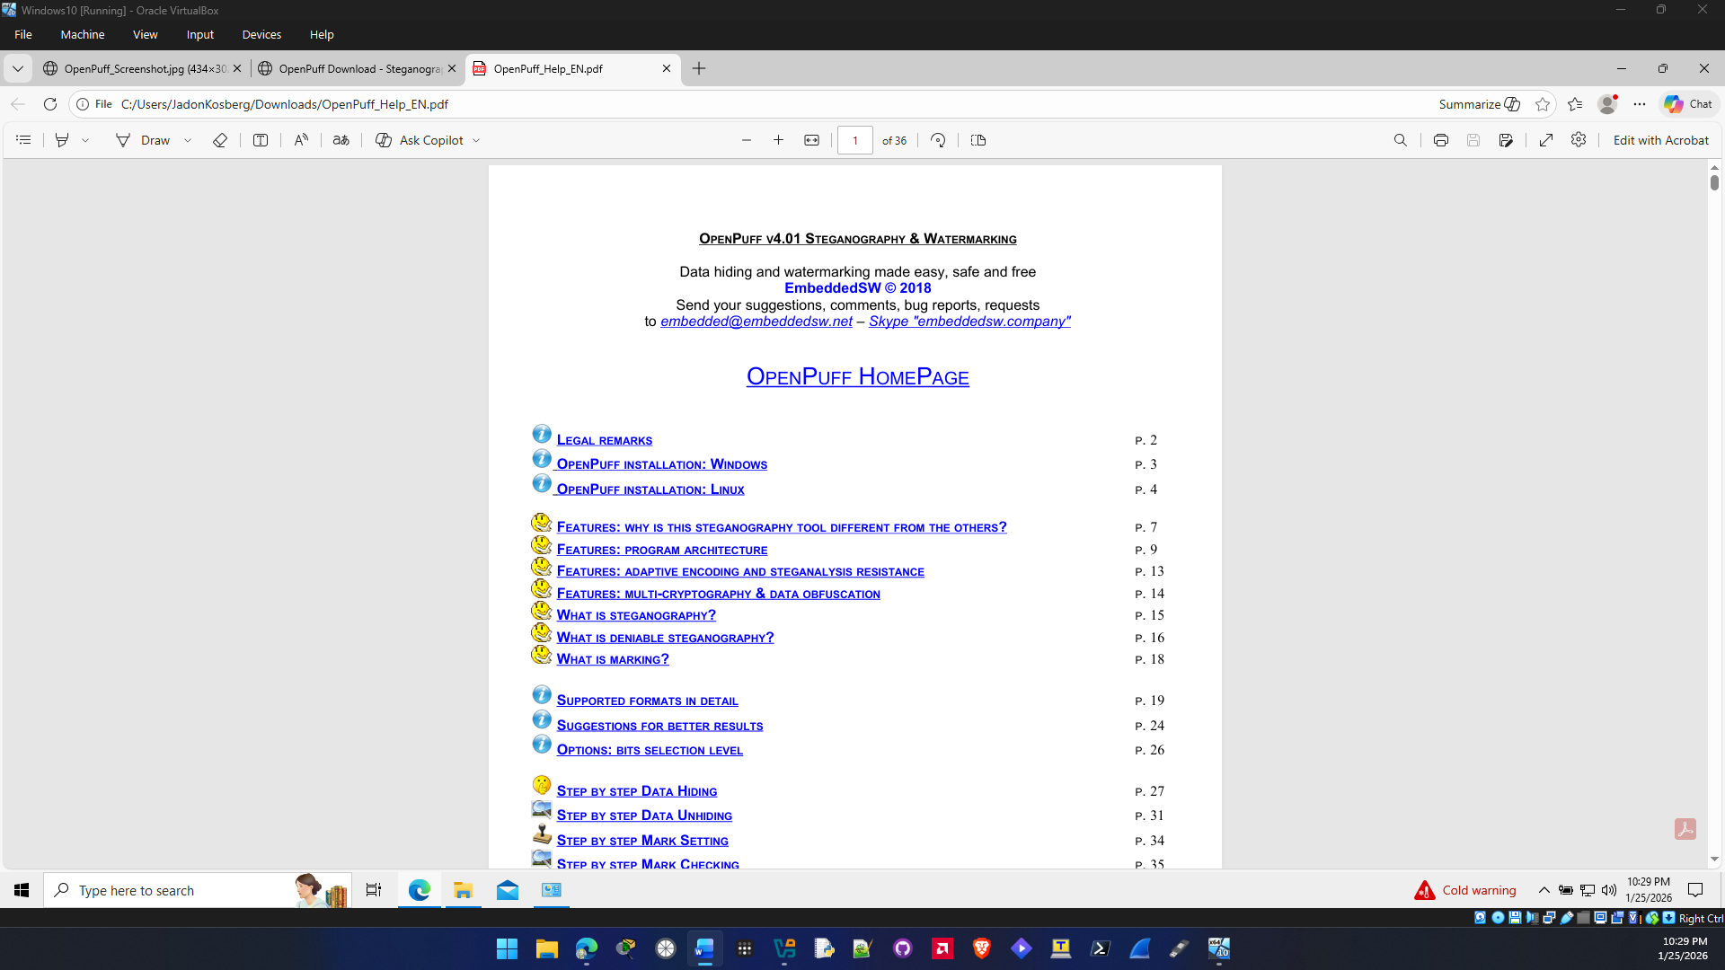

- Click Hide Data!.
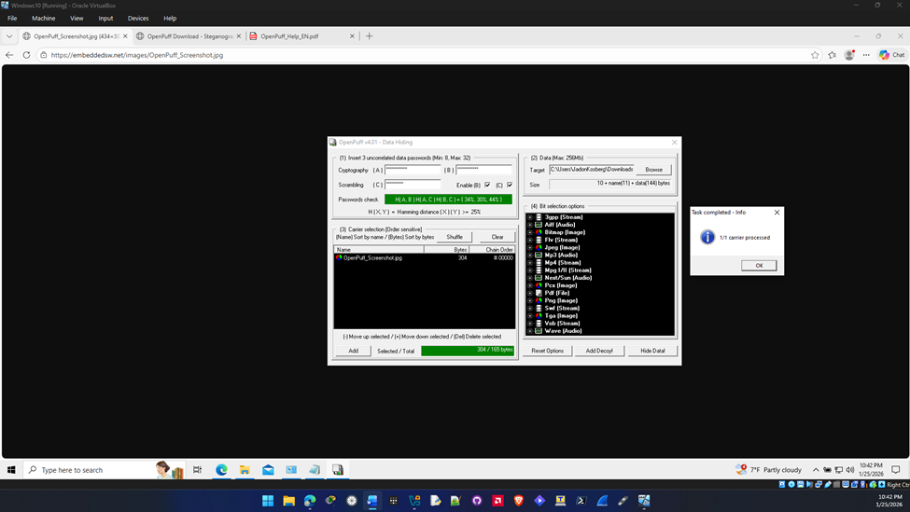

- After the processing has completed, navigate to the location of the carrier file that contains the message and open the file. Can you detect anything different with the file now that it contains the message?
Nothing is different from the appearance of the photo, but the file size of the carrier file is slightly different the original is 106,246 bytes and the carrier is 106,238 bytes.

- Click Unhide!.
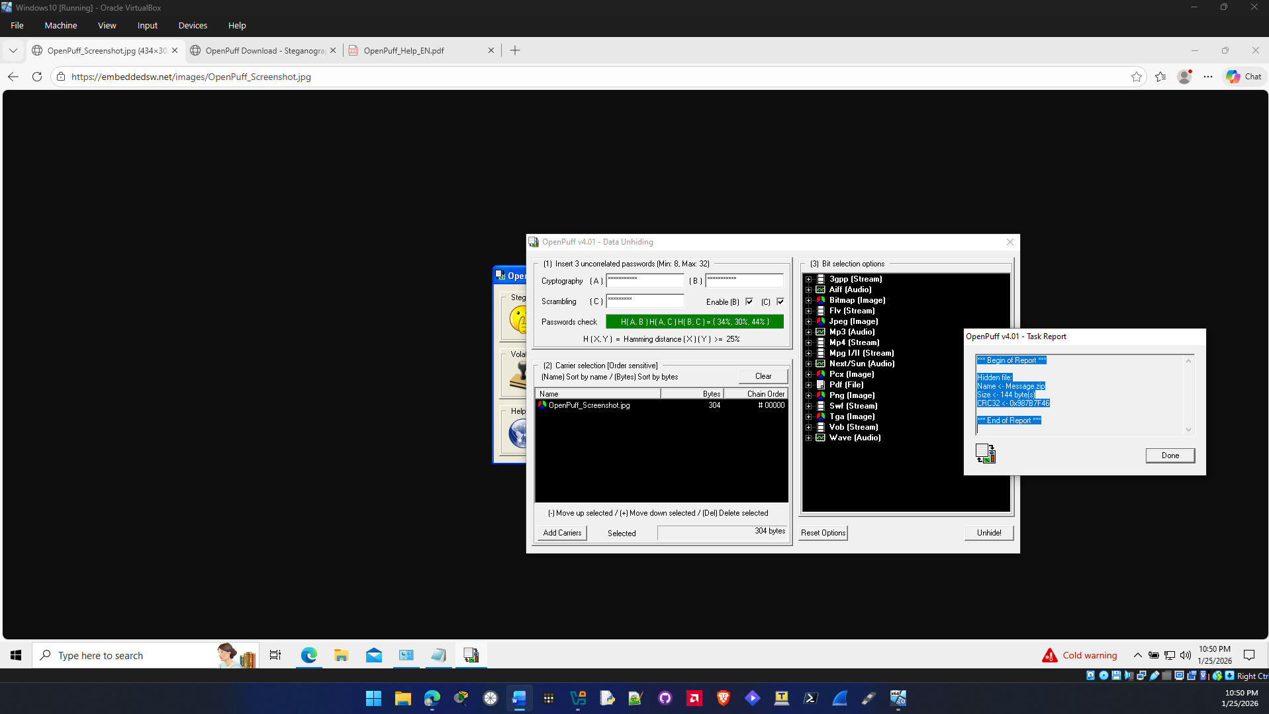

- Go to the location of the hidden message and you will see Message.zip.
